**Project Design Phase-II**

**Solution Requirements (Functional & Non-functional)**

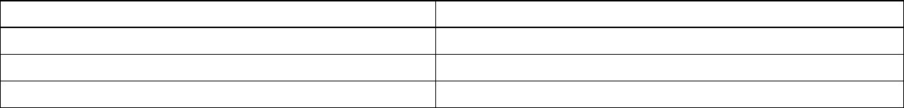

Date

Team ID

Project Name

Maximum Marks

21

October 2022

PNT2022TMID08105

ANALYTICS FOR

HOSPITALS

’

HEALTH

-

CARE DATA

4

Marks

**Functional Requirements:**

Following square measure the purposeful needs of the projected resolution.

|  |  |  |
| --- | --- | --- |
| **FR No.** | **Non-Functional Requirement** | **Description** |
| NFR-1 | **Usability** | Dashboards square measure created so as to show the length of stay prediction in a visual manner. So, the predictions are often simply understood |



**FR No.**

**Functional Requirement (Epic)**

**Sub Requirement (Story / Sub**

**-**

**Task)**

FR

-

1

User Registration

Registration through

Form

FR

-

2

User Confirmation

Confirmation via Email

or

Confirmation v

ia

OTP

F

R

-

3

User Login

Login

explo

itation

the given credentials

FR

-

4

Dataset

Upload the dataset to the dashboard

FR

-

5

Analysis

Data is pre

-

processed and clea

n. Once

c

lean

up

the

exploration

m

e

thod

is

do

le

out

FR

-

6

Prediction

Machine learning

rul

e i

s

employed

for prediction

FR

-

7

Visualization

Visualization of the prediction is shown

with

in the

dashboard created

exploitation

IBM Cognos Analytics

**Non-functional Requirements:**

Following square measure he non-functional needs of the projected resolution.

|  |  |  |
| --- | --- | --- |
| NFR-2 | **Security** | The dataset uploaded to the dashboard can’t be downloaded or accessed by external sources. |
| NFR-3 | **Reliability** | A dashboard created once the prediction method can be additional reliable and shows the result clearly and effectively. |
| NFR-4 | **Performance** | the prediction has additional accuracy. |
| NFR-5 | **Availability** | Predicted informations are going to be obtainable a few time once the prediction. |
| NFR-6 | **Scalability** | This system can predict the length of stay of all kinds of patients |